Berryessa Chinese School 2016-17
CFL4A Week 23
Teacher: Jeanette Lin (林銘慧) Phone: (408) 287-1231
Website: http://forestchineseschool.weebly.com/ Email: writerjeanette@gmail.com
Homework Feedback
Writing  Great很好  Need to make corrections  Incomplete/missing | Recording  Great  Need some work  Incomplete/missing | Typing  Great  Need some work  Incomplete/missing
Announcement | My child has completed all the homework  Parent’s signature簽名 | Grade 分數
Date: March 25, 2017 中文姓名: ____________
Homework Assignments:
A. Do worksheets 23-4, 23-5 and 23-6. Staple them to this packet.
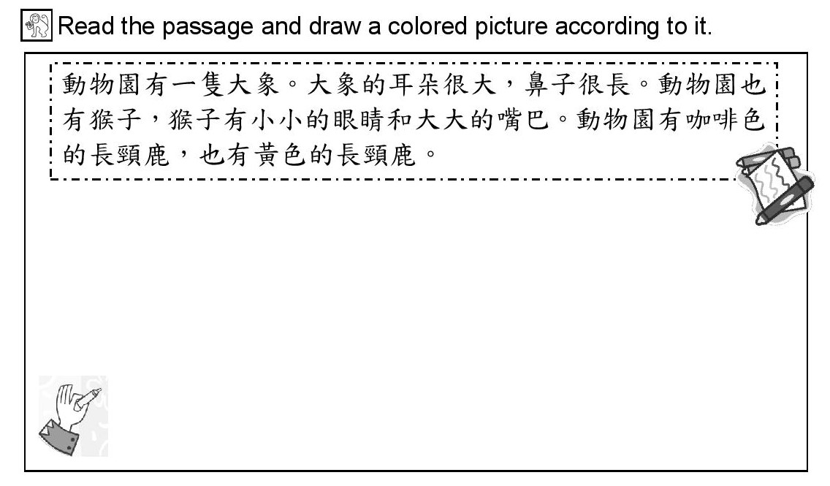
B.

- Identify five radicals from the words in the circle. Write down each radical and then group the characters according to each radical.

- Radical ______________ characters_____________________________________________
- Radical ______________ characters_____________________________________________
- Radical ______________ characters_____________________________________________
- Radical ______________ characters_____________________________________________
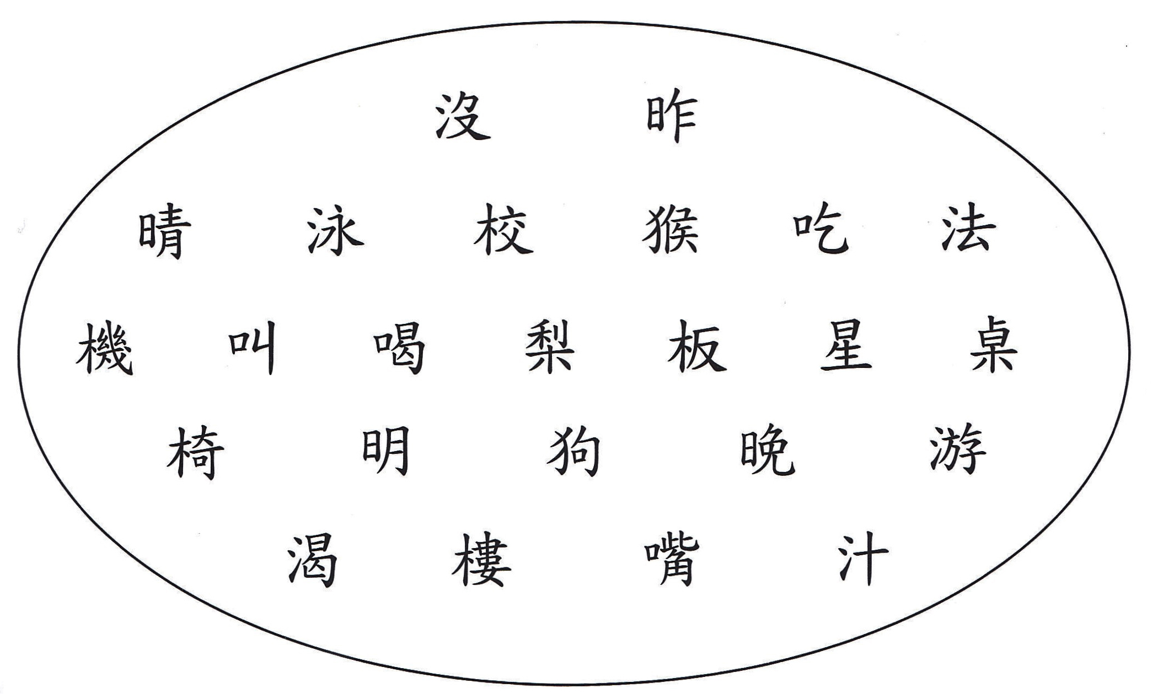
- Radical ______________ characters_________________________________________

